PowerSchool Report Card Parent/Guardian Access Guide

1. Open up the nfschools.net webpage in your web browser.
2. Click on the “Parent Portal” button to open the login page.

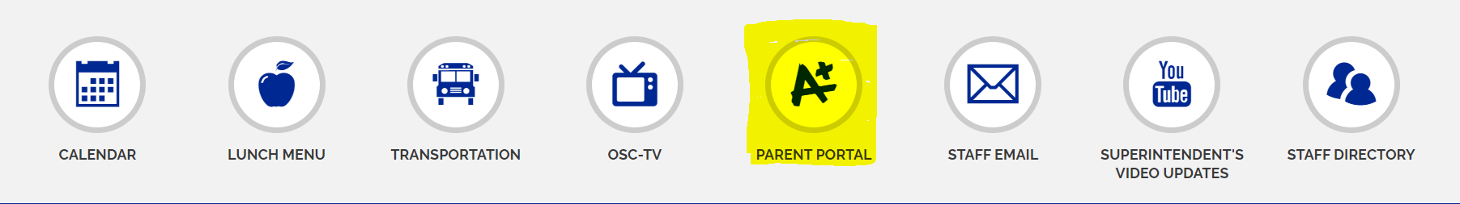

1. Login to the NF Schools Student/Parent PowerSchool sign-in page and select the proper student.

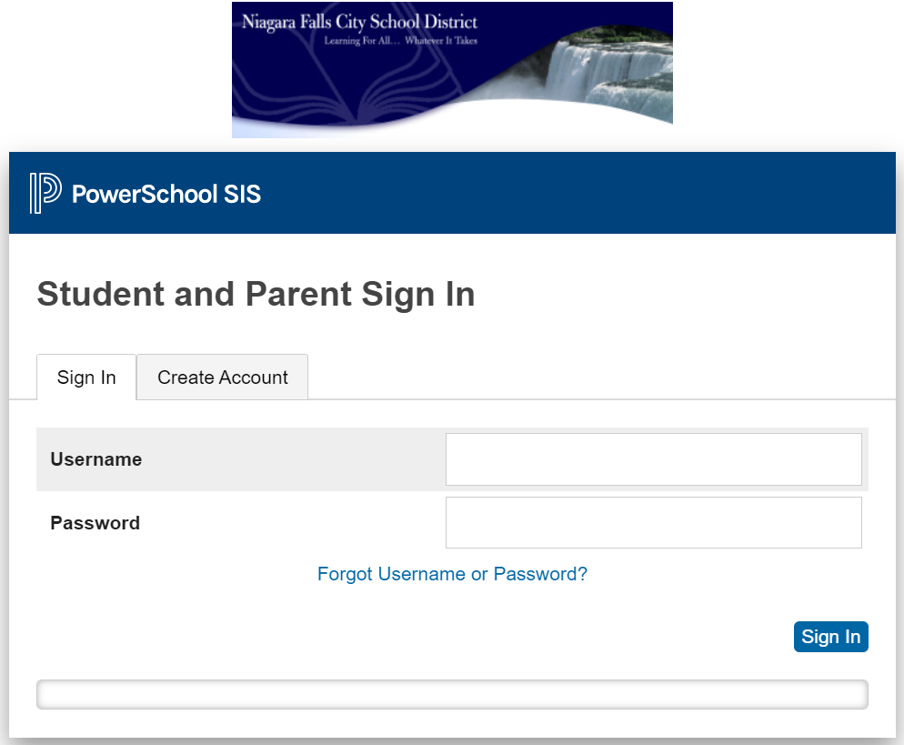

1. On the left-hand side, within the “Navigation” toolbar, click on the “Report Card” icon.

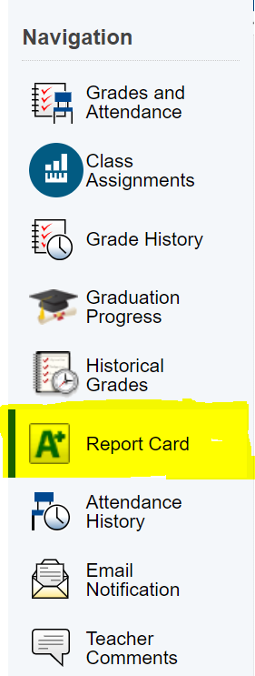

1. The report card should then be displayed on the page!

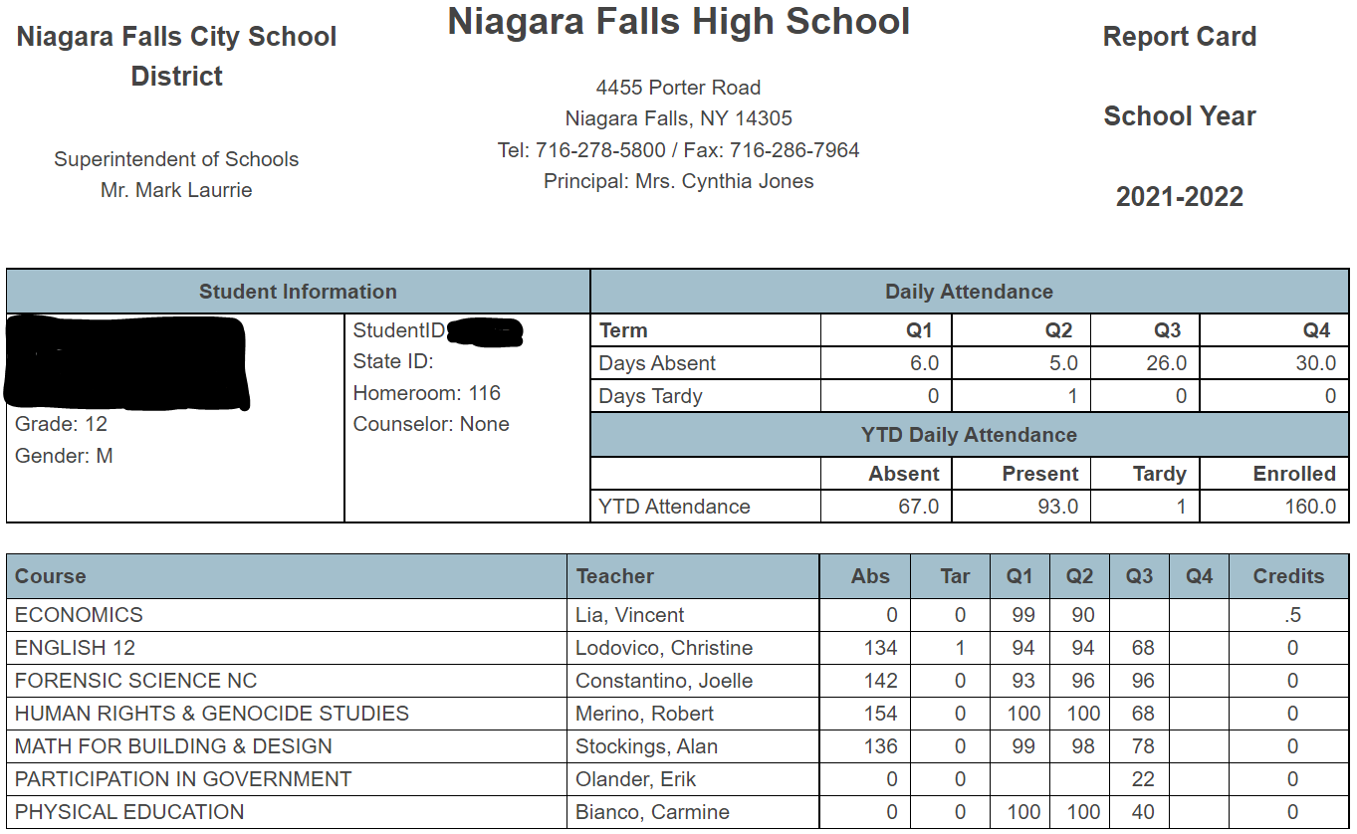

Further Navigations:

In order to view the Student’s Exam grades, go to the following:

1. On the left-hand side, within the “Navigation” toolbar, click on the “Historical Grades” icon.

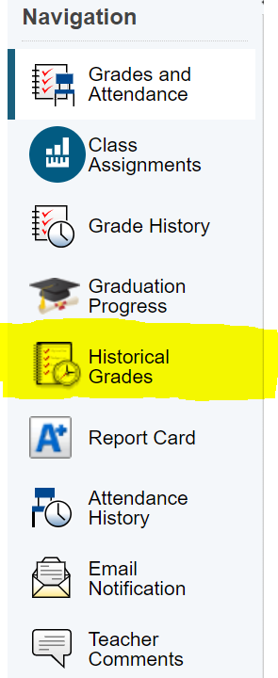

1. 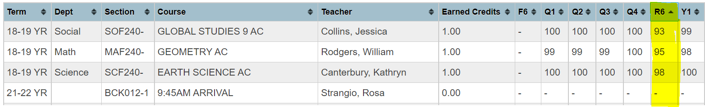Within the “R6” column, you should be able to view each Exam grade by class.

In order to view the Student’s GPA & Standards, go to the following:

1. On the left-hand side, within the “Navigation” toolbar, click on the “Grades and Attendance” icon.

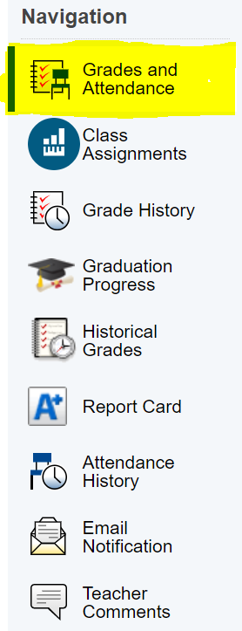

1. Scrolling about half way down the page, the following will be displayed:

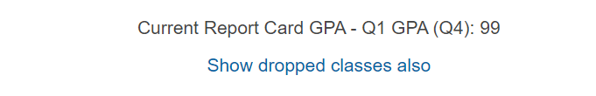

1. Within that same page, select the “Standards Grades” tab at the top, in order to view the Student’s standards grades.

